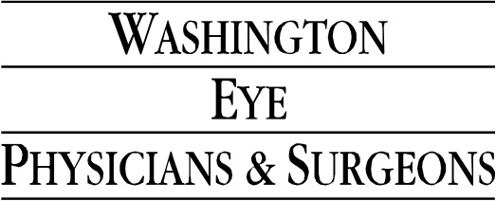

Aisha Macedo, M.D.
Dr. Aisha Macedo has been with the Washington Eye Physicians and Surgeons since the beginning of 2012.
She entered the private practice arena after completing a Cornea fellowship at the prestigious Wilmer Eye Institute which is affiliated with the Johns Hopkins Hospital. While at the Wilmer Eye Institute, Dr. Macedo invented an instrument that is currently being used by ophthalmologists to advance a special type of corneal transplantation called DSAEK.
Dr. Macedo is a highly skilled ophthalmic surgeon whose surgical armamentarium includes cataract extraction, refractive surgery (e.g. PRK, LASIK), clear lens exchange, corneal transplantation and the treatment of ocular surface lesions. In addition to her private practice, Dr. Macedo is an integral component to resident education at the Georgetown Department of Ophthalmology.
Dr. Macedo is a member of the American Academy of Ophthalmology and has completed an accredited fellowship in Cornea, External Disease and Refractive Surgery at the Wilmer Eye Institute.
Her research interests include cataract formation, corneal dystrophies, treatment modalities for keratoconus, and technologic advances in refractive surgery.


As a native Canadian, she is fluent in French, in addition to Spanish and English. She has spoken both nationally and on the local academic circuit and has published several academic journal articles and book chapters.
Dr. Macedo is dedicated to optimizing your visual system to allow you see the world clearly. For a consultation with Dr. Macedo in Chevy Chase or Silver Spring, please call 301-657-5700.
Education
Wilmer Eye Institute, Johns Hopkins Hospital, Baltimore, MD, fellowship in Cornea, External Disease and Refractive Surgery
Mount Sinai School of Medicine, New York City, NY, Ophthalmology residency
Mount Sinai School of Medicine, Doctorate of Medicine, New York, NY
Duke University, Durham, NC, BSc.

